Explore Egypt / Team 12

Explore Egypt
Software Design Specification (SDS)
Version: 1.1
CM Identifier: G12_SE02_v1.1

Revision History

Sl. No. | Prepared/  Modified by | E-mail | Version | Date | Approved by | Descriptions/  Remarks
1. | Chahira Hamza | Chahira.hamza@live.com | 1.0 | 04-09-2018
2. | Nooran Helmy | Nooran.helmi@hotmail.com | 1.1 | 9 April 2018

Distribution list

Name | E-mail | Notes
TA: Eng. Ali Elseddeek | alielseddeek@gmail.com
TA: End. Dina Elreedy | dinaelreedy@gmail.com

Table of Contents
1.Introduction 7
1.1Purpose of this Document 7
1.2Scope 7
1.3Table of Acronyms and Definitions 7
1.3.1Definition 7
1.4 References 7
1.5 Overview of Document 8
2.System Architecture 8
3.Design Models 8
3.1Design Patterns Description 9
3.1.1Design Pattern I 9
3.1.2Design Pattern II 9
3.2Class Diagrams 9
3.3Interaction Diagrams 9
3.4State Chart Diagrams (if needed) 9
3.5Activity Diagrams (if needed) 9
3.6Component Diagrams (if needed) 9
4.Data Models 9
5.System Deployment 9
6.Traceability to Requirements 9

List of Tables

List of Figures

Introduction

Purpose of this Document
The purpose of this document is to set guidelines for the implementation phase. It provides an overview of the system architecture and the design patterns used.

Scope

Explore Egypt is a web application that are intended to encourage tourism in Egypt. It facilitates to the tourist the sites s/he can visit in every governorate in Egypt, gives information about the sites and their history. It also targets domestic tourism as it reveals the hidden places in Egypt.

Table of Acronyms and Definitions

Term | Definition
SDS | Software Design Specifications
GUI | Graphical User Interface
DB | Database
MVC | Model View Controller

References
N/A

Overview of Document
The document describes the system architecture and the main components of the project. Then it describes the design patterns chosen and the reason for choosing them.

System Architecture
The System architecture provides an overview of the system's major components and architecture.
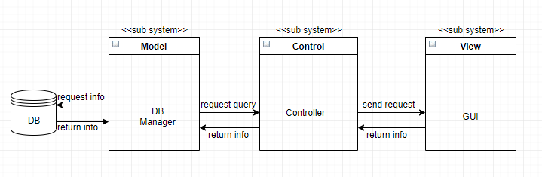

Figure 1 – System Architecture

The architecture of the project is following the MVC model, it is composed of three layers. The first layer is the GUI through which the user navigate through the website and use the functionalities. The second layer is the controller which controls which functionality each user should have and request a query from the DB manager depending on the functionality the user wants. The third layer is the Model and the database, the model gets the information which is stored in the database and passes it to the controller which passes it to the view so that the user can see it.

Design Models
<This should contains class, interaction, activity and state chart diagrams that models your system. Diagrams may contain classes from different subsystem/layers. Remember that your design should be complete and no ambiguities should appear. Developers will have to translate these diagrams into code. Assign each design element (class, sequence) an ID that can be used in the traceability matrix>

Design Patterns Description

Design Pattern I : MVC
We have used the architectural MVC model in order to separate the 3 modules (Model, View, Control) from each other, so that each module can be independent. This design pattern facilitates the division between the team members in terms of tasks. The GUI representing the View module aggregates all the html files in use in the project. For each input from the user, a servlet is created which is a mini Control module that controls only this specific input. Finally a Model class that contains all the needed operations in the project and which handles the connection with the database.

Design Pattern II
Not applicable in this phase.

Class Diagrams
<You should use one or more class diagram to model the relationships between the classes of the system. Each class diagram may contain classes from different layers.>

Interaction Diagrams
<For each service provided by the system, you should use sequence diagrams to model the interaction between objects to realize this service. Each sequence diagram may contain classes from different layers.>

State Chart Diagrams (if needed)
<You may use state chart diagrams to model how individual objects change their state in response to events or to model how the subsystem changes its sates.>

Activity Diagrams (if needed)
<You may use activity diagrams to model the work flow inside the subsystem or to model a specific operation/algorithm.>

Component Diagrams (if needed)
<You should use component diagrams to model the organization and dependencies among the source files of this system>

Data Models
<You should use entity-relationship diagrams to model the database relationships for the database maintained by the system.>

System Deployment
<You should use component and deployment diagrams to model how the system will be deployed. First, use component diagrams to model the organization and dependencies among the system executable components. Second, use deployment diagrams to model the configuration of run time processing nodes and the components that live on them>

Traceability to Requirements
<This should maintain a matrix similar to the Traceability Matrix in the Software Requirements Specification document. The purpose of this matrix is to map requirements to design elements. This will immediately point out requirements that have not been considered. It will also allow you to trace into the design elements that require to be changed if requirements change. Use requirement IDs as row headers and design element IDs as column headers>

